Create a S3 bucket

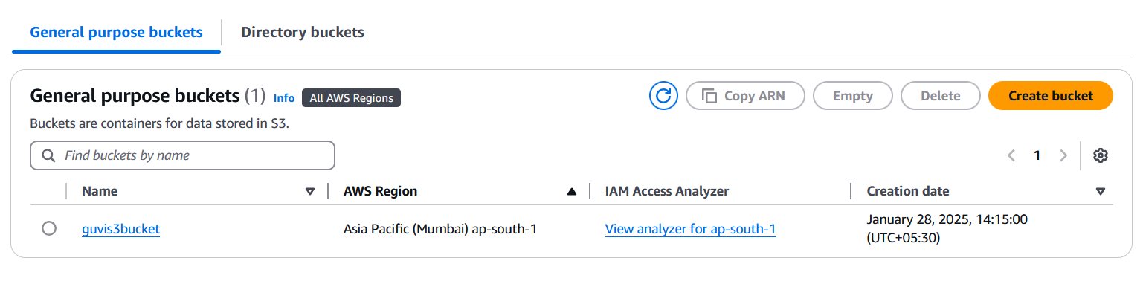

No public access

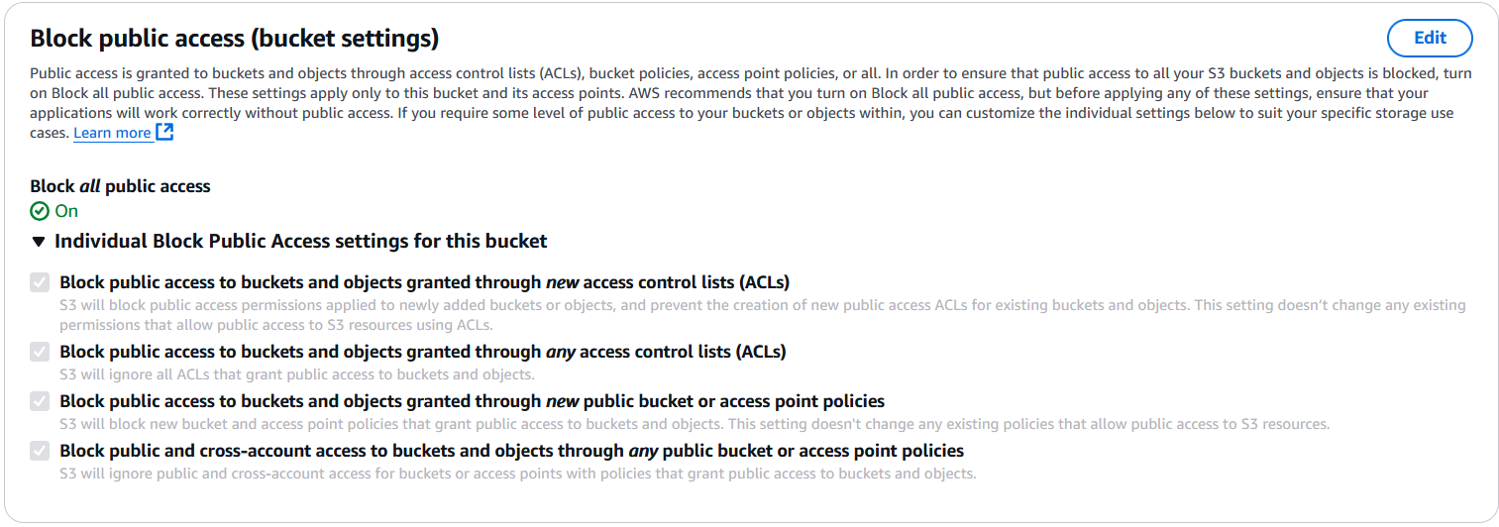

upload files to the bucket

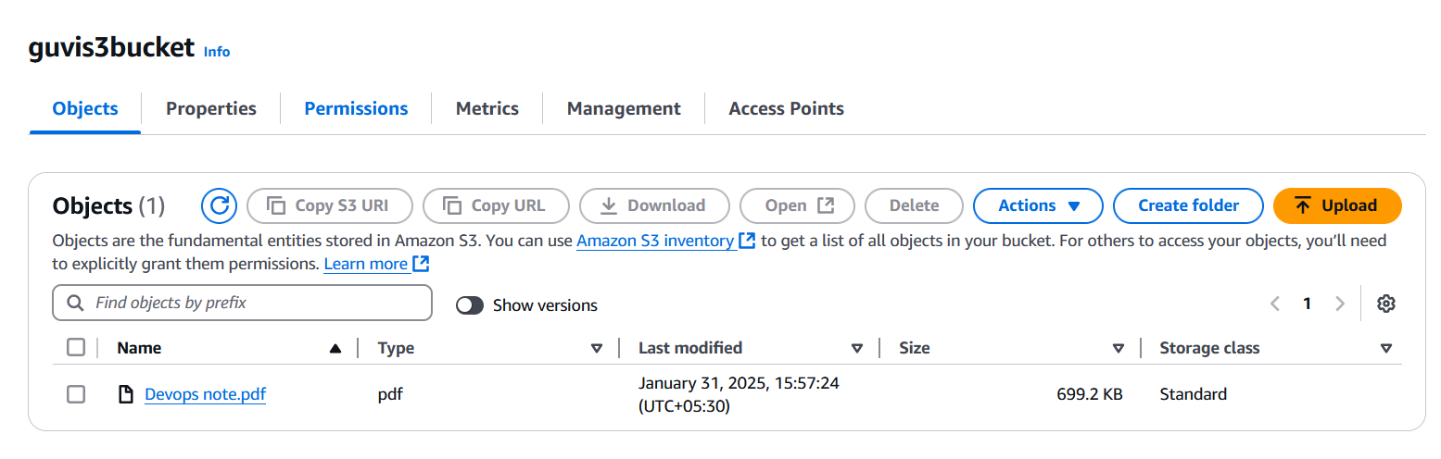

view the logs using cloud watch for the uploaded files

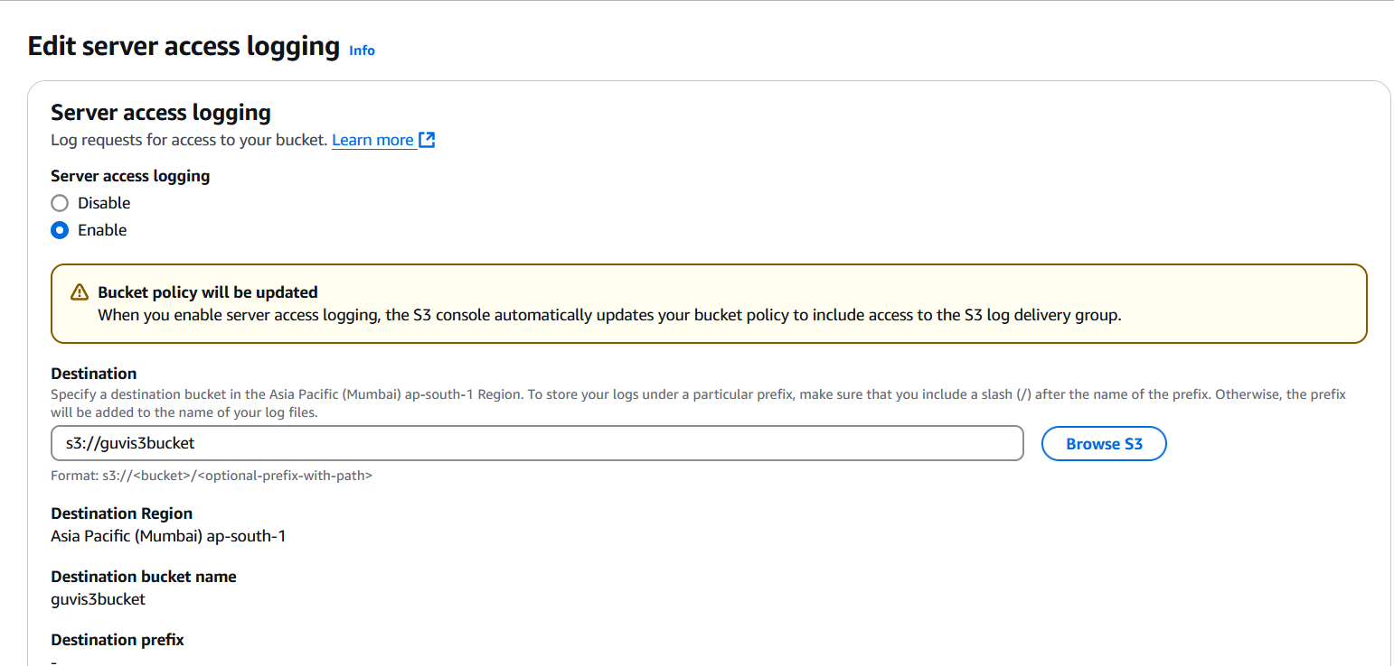

Launch two ec2-instances and connect it to a application load balancer

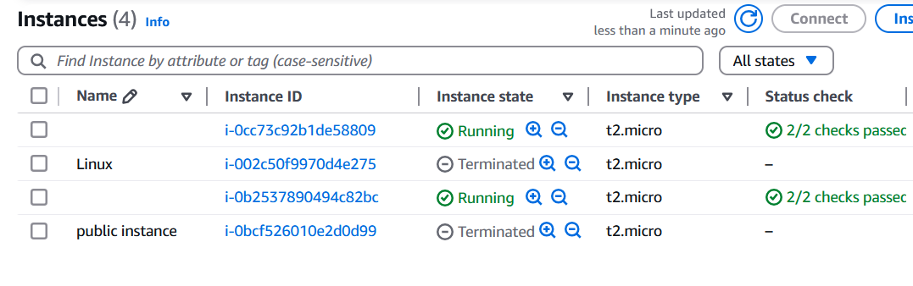

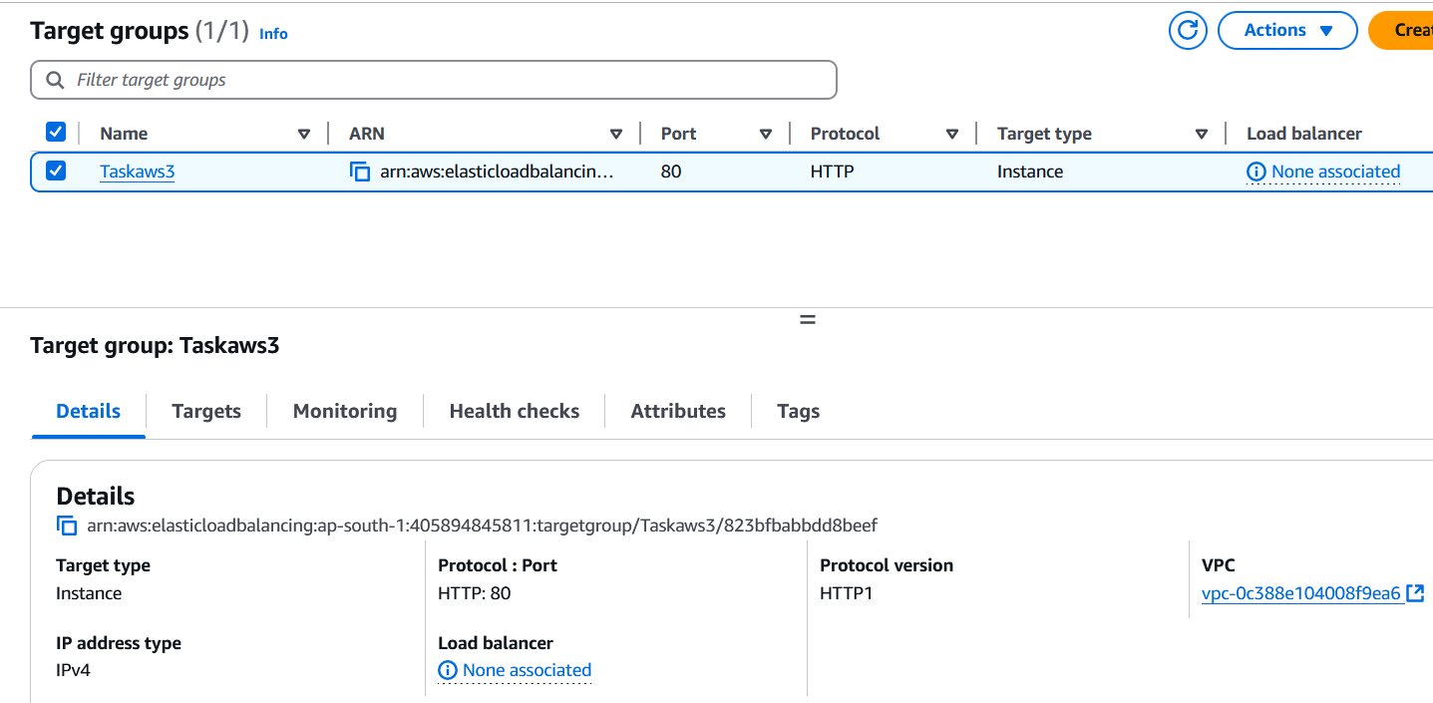

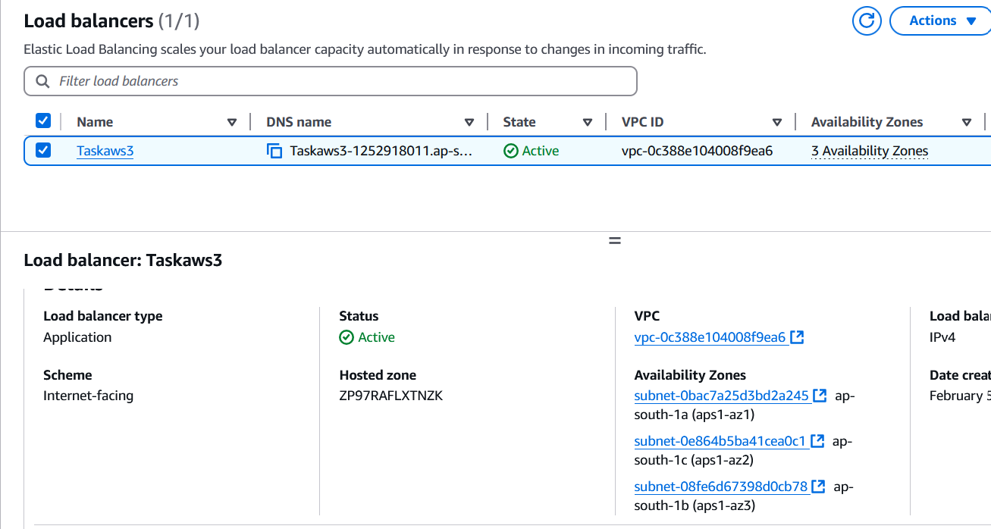

where the output traffic from the server must be an load balancer IP address

